**DIFFERENT TYPES OF CHARTS USED FOR VISUAL ANALYTICS**

**#1 Line Graphs**

The most common, simplest, and classic type of chart graph is the line graph. This is the perfect solution for showing multiple series of closely related series of data.  Since line graphs are very light-weight (they only consist of lines, as opposed to more complex chart types, as shown further below), they are great for a minimalistic look.

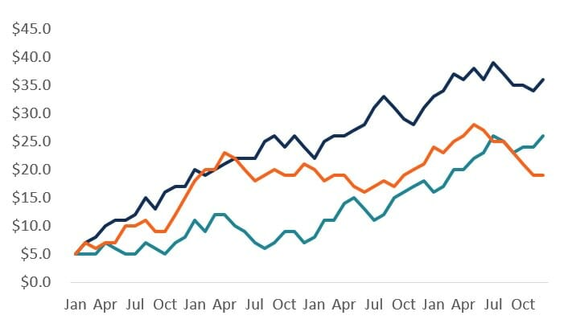

### #2 Bar Graphs

Bars (or columns) are the best types of graphs for presenting a single data series. Bar charts have a much heavier weight to them than line graphs do, so they really emphasize a point and stand out on the page.

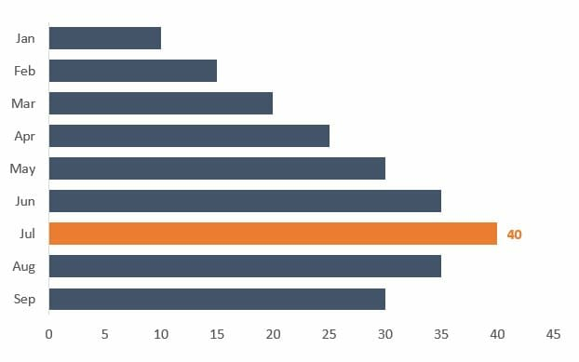

### #3 Combo Chart

The above two types of graphs can be combined to create a combo chart with bars and lines.  This is very useful when presenting two data series that have a very different scale and might be expressed in different units.  The most common example is dollars on one axis and percentage on the other axis.

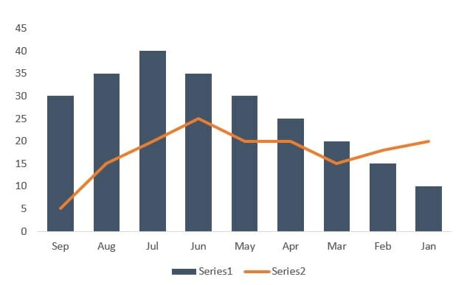

### #4 Scatterplot

The scatterplot is excellent for showing the relationship between two data series and determining their correlation.  The scatterplot is great for showing what a distribution of data points looks like and for drawing a line of best fit for regression analysis.

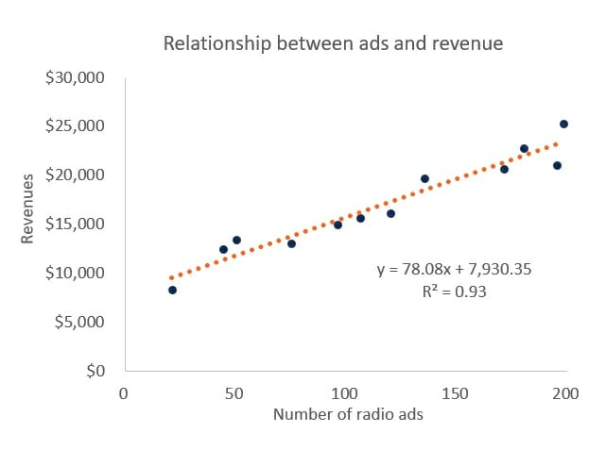

### #5 Waterfall Chart

In Excel 2016, Microsoft finally introduced a waterfall chart feature.  In all older versions of Excel, analysts had to create a custom workaround using stacked column charts. The waterfall chart is excellent for variance analysis and explaining how an “actual” result was different than a “budget” or how something has changed relative to an original data point.

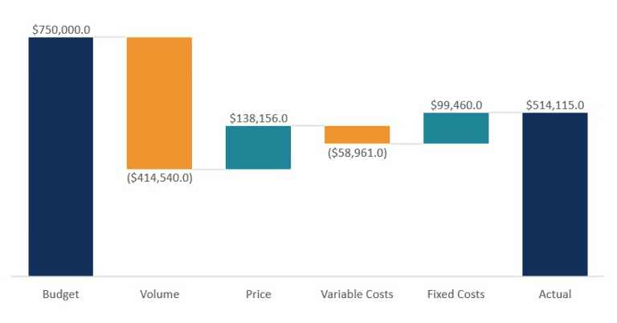

### #6 Pie Graph

Pie charts have a bad reputation and are known for being messy and hard to read.  However, if you’re trying to illustrate the percentage breakdown of a small number of data points, then they can be very effective.  For example, the percentage of people who prefer bananas, pineapples, and grapes.

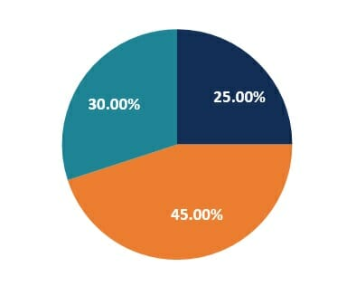

### #7 Histogram

Histograms are a type of graph that shows the distribution of a dataset. They graph the percentage or the number of instances of different categories.  For example, to show the distribution of age categories (0-10, 11-20, 21-30, etc.), we can clearly see which categories are the biggest and how many people fall into each.

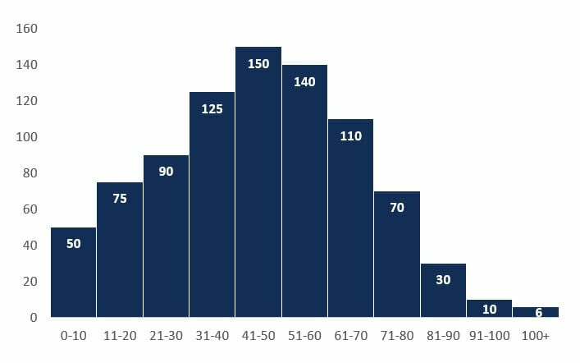

**#8 Gauge Chart**

The gauge chart is perfect for graphing a single data point and showing where that result fits on a scale from “bad” to “good”.  Gauges are an advanced type of graph, as Excel doesn’t have a standard template for making them.  To build one you have to combine a pie and a doughnut.  Learn how in our data visualization course.

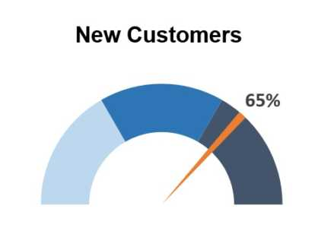

### #9 Area Graph

An area chart is a solid area and can be effective when showing stacked, cumulative data series – for example, showing the cumulative sales revenue from different products.  This allows the reader to easily visualize the “area” (or weight) of each series relative to each other.

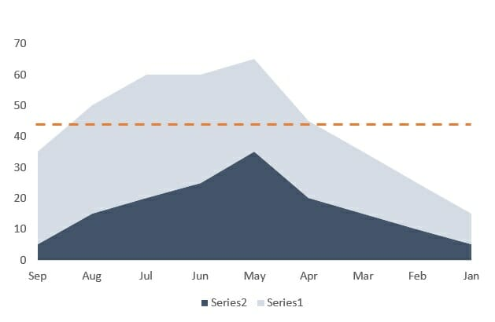

### #10 Spider chart / radar graph

A spider or radar graph is a very useful type of graph for showing qualitative data or the overall “score” or comparison of multiple series.  For example, a spider/radar can be easily used to compare three different types of phones based on five criteria (speed, screen size, camera quality, memory, apps).

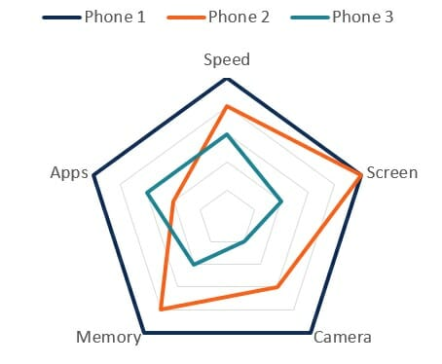

### #11Flow Charts

Oftentimes in business – as well as other industries – a process must be diagrammed. A flow chart allows a process to be sequenced step-by-step, from beginning to end, for the purpose of analyzing, designing, documenting or managing it.

These flow charts can even feature multiple beginnings and ends, with countless pathways and journeys in between.

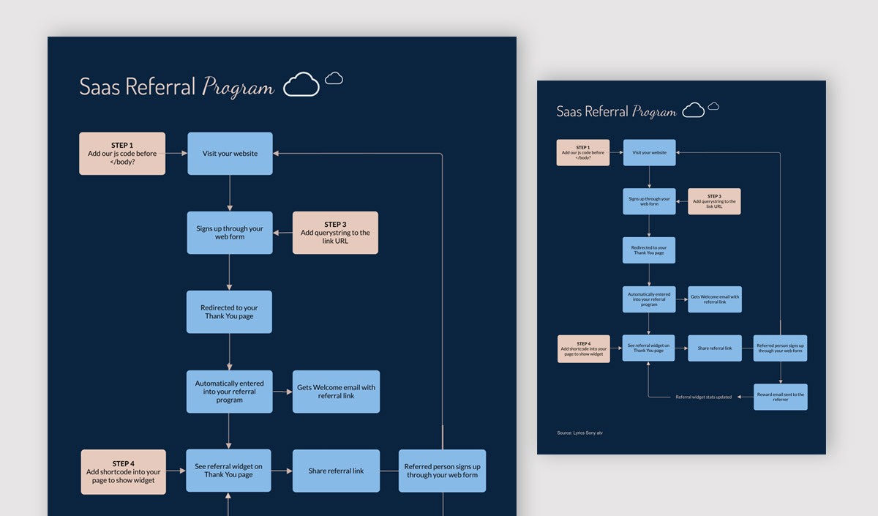

### #12Gantt Charts

Gantt charts are special types of bar graphs used to diagram projects and schedules. The use of colored bars of varying lengths reflect not only a project’s start and end dates, but also important events, tasks, milestones and their timeframes.

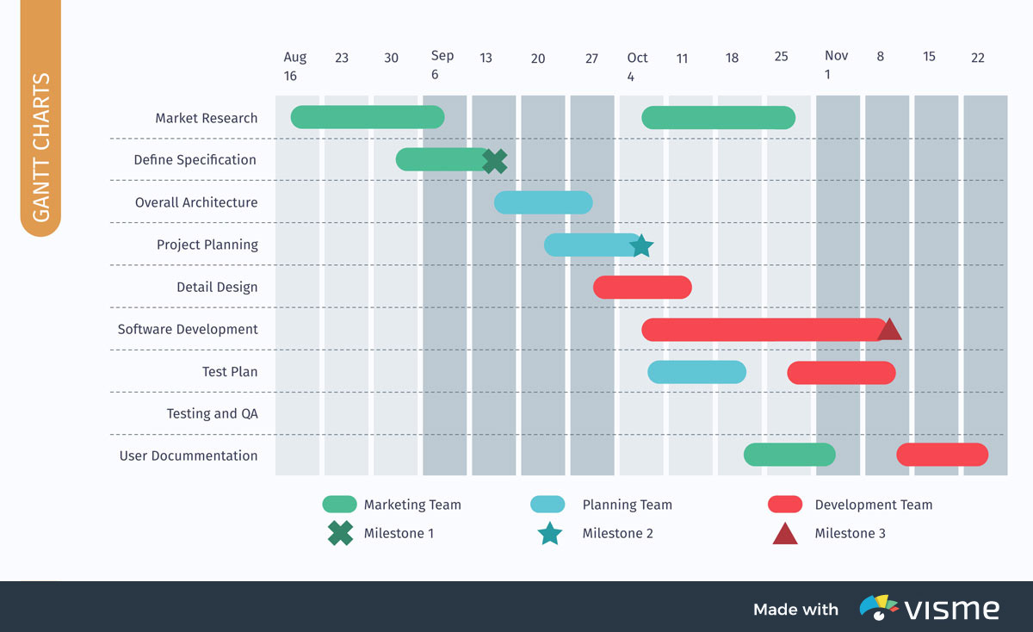

### #13Hierarchy Diagrams

Similar in appearance to a flow chart, a hierarchical diagram, also known as an organizational chart or an organigram, illustrates the structure of an organization, as well as the relationships within it.

A typical company organigram, for example, lists the CEO at the top, followed by presidents, vice presidents, managers and so on.

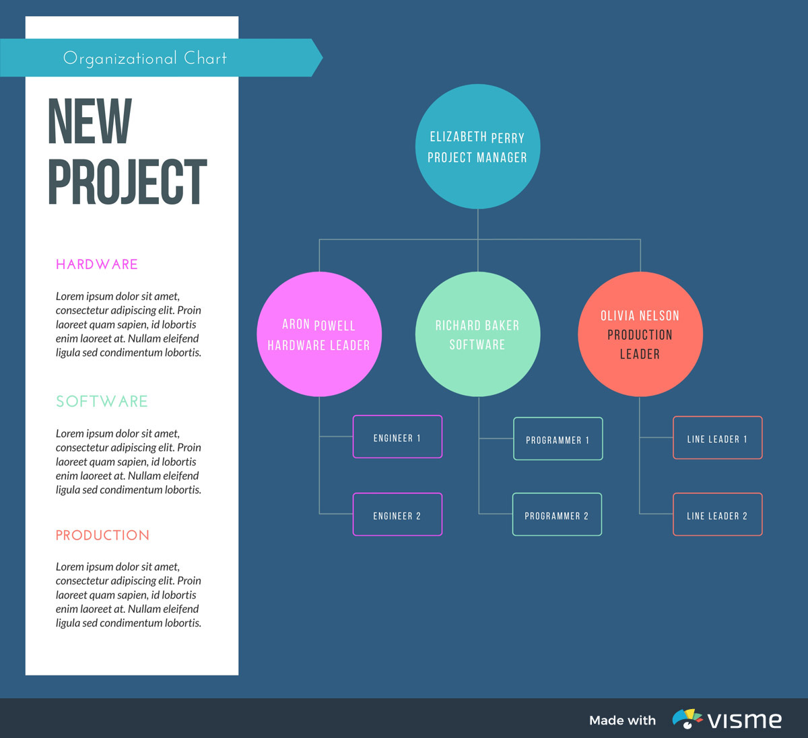

### #14Sunburst Charts

A type of multi-level pie chart, a sunburst chart is used to illustrate hierarchical data using concentric circles. Each ring of the “sunburst” represents a level in the hierarchy, with the root node represented by the center circle, and the hierarchy moving outward.

While a sunburst chart can be used to illustrate a familiar or company hierarchy, it can also break data down by time periods, creating a historical hierarchy

